Maintainability- STATIC ANALYSIS

*AvoidDuplicateLiterals
-Code containing duplicate String literals can usually be improved by declaring the String as a constant field.
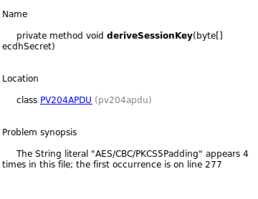
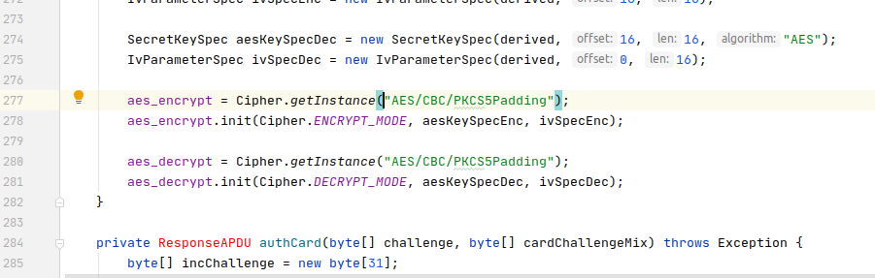

*CyclomaticComplexityCheck
-Checks cyclomatic complexity of methods against a specified limit. The complexity is measured by the number of if, while, do, for, ?:, catch, switch, case statements, and operators && and || (plus one) in the body of a constructor, method, static initializer, or instance initializer. It is a measure of the minimum number of possible paths through the source and therefore the number of required tests. Generally 1-4 is considered good, 5-7 ok, 8-10 consider re-factoring, and 11+ re-factor now !
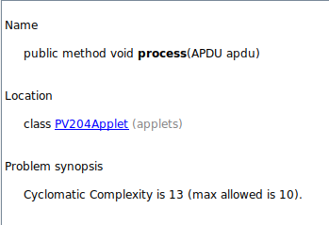

*EmptyWhileStmt
-Empty While Statement finds all instances where a while statement does nothing. If it is a timing loop, then you should use Thread.sleep() for it; if it's a while loop that does a lot in the exit expression, rewrite it to make it clearer.

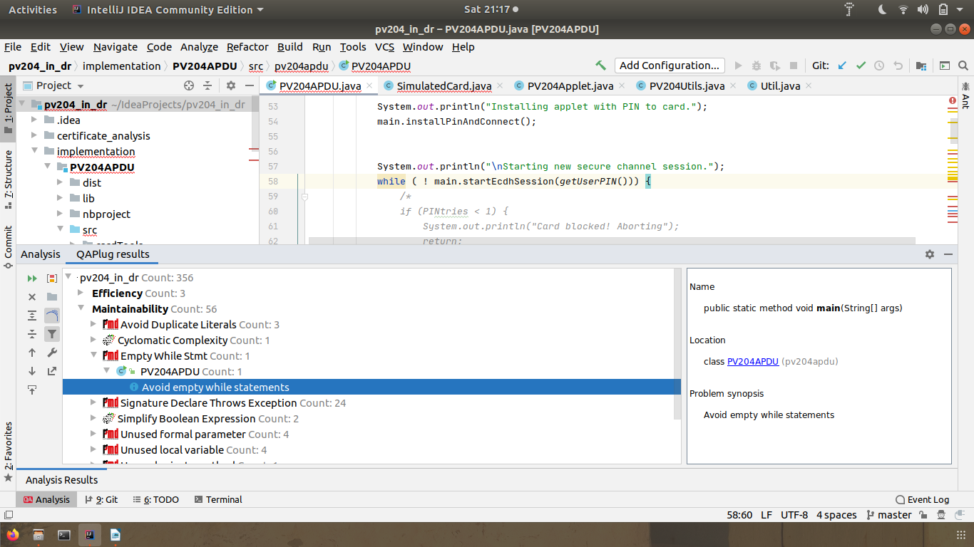

*SignatureDeclareThrowsException
-It is unclear which exceptions that can be thrown from the methods. It might be difficult to document and understand the vague interfaces. Use either a class derived from RuntimeException or a checked exception.
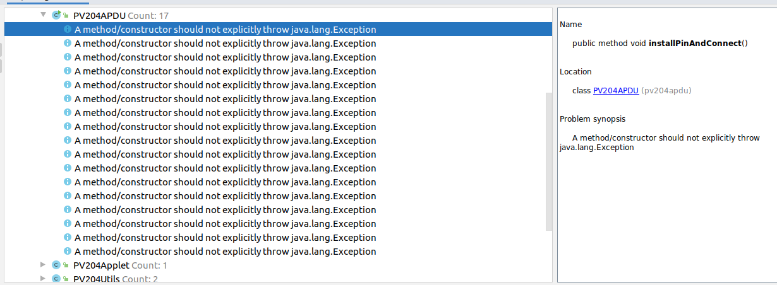

*SimplifyBooleanExpressionCheck
Checks for overly complicated boolean expressions.
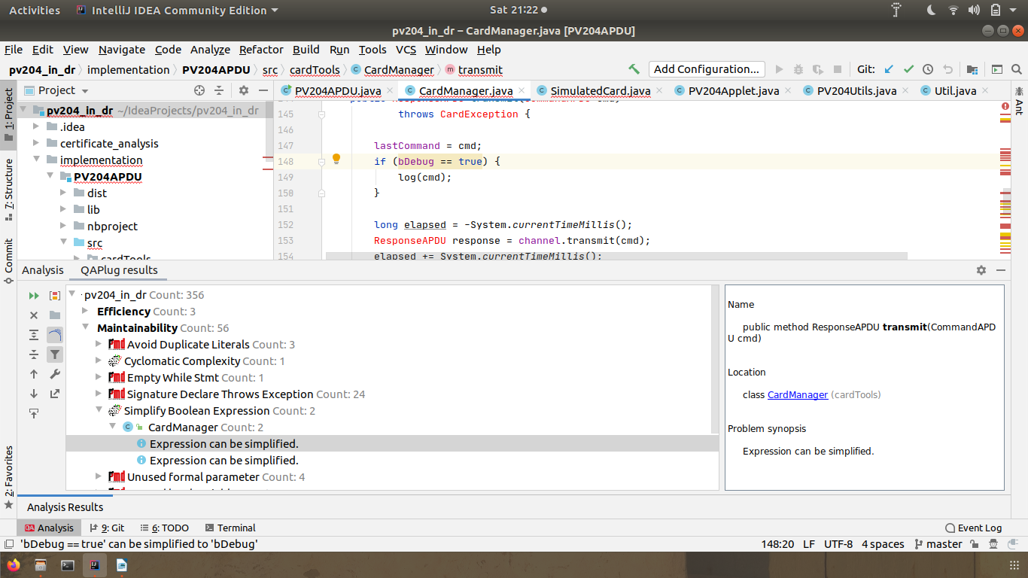

*UnusedFormalParameter
-Avoid passing parameters to methods or constructors and then not using those parameters.
